To run the trained model: zombie -Model.py

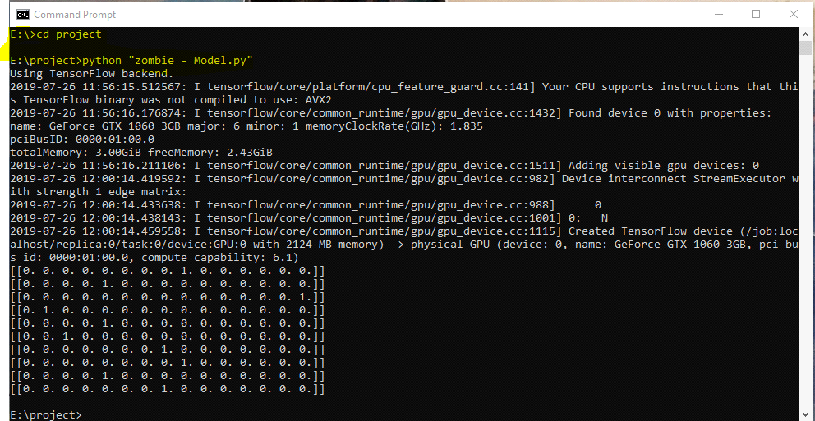

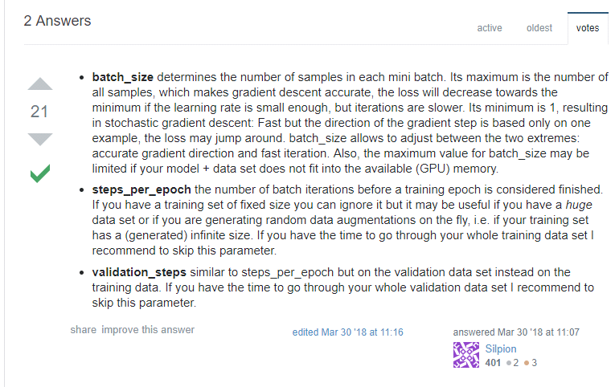

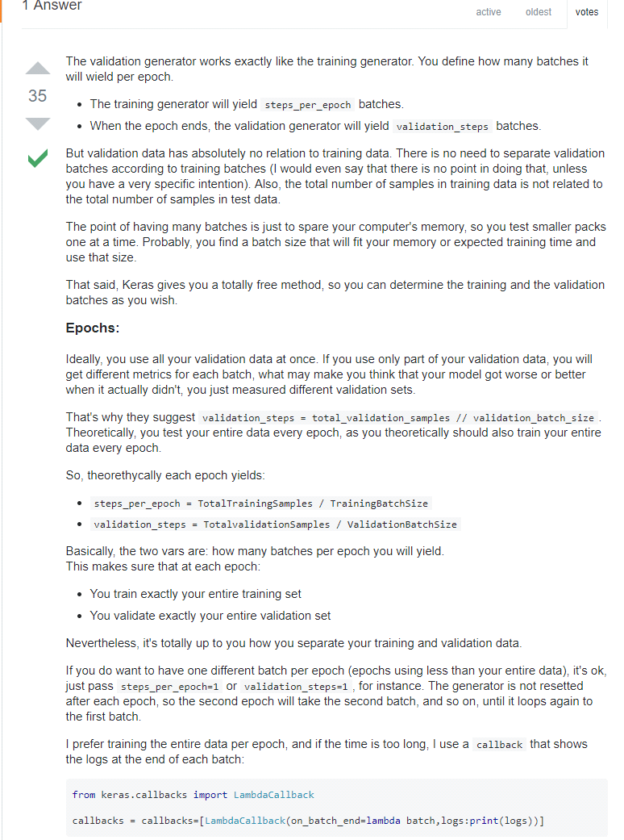

20 Classes

steps_per_epoch = 450 ; validation_steps = 450

/test_models/20class450epoch.h5

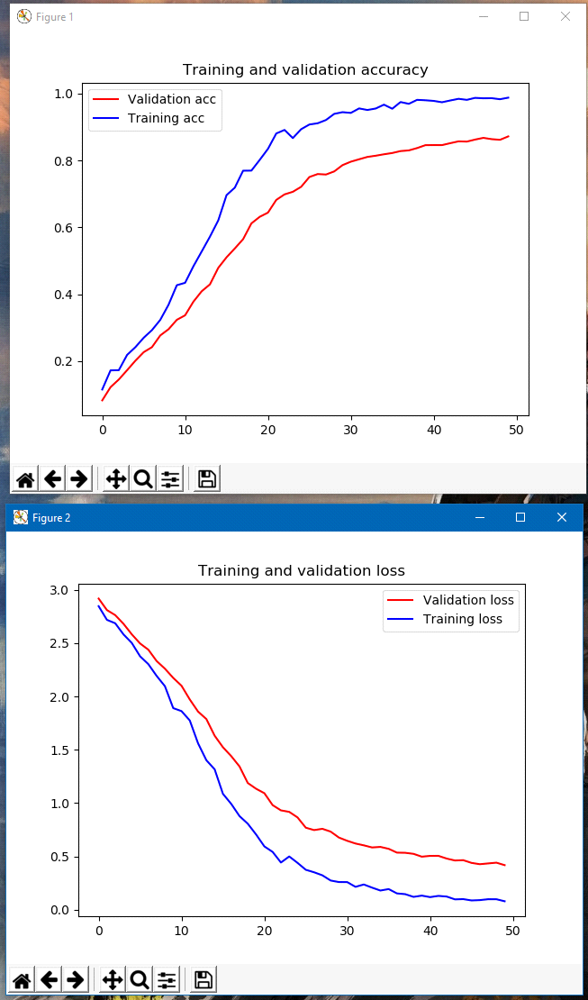

20 Classes

steps_per_epoch = 625 ; validation_steps = 625

/test_models/20class625epoch.h5

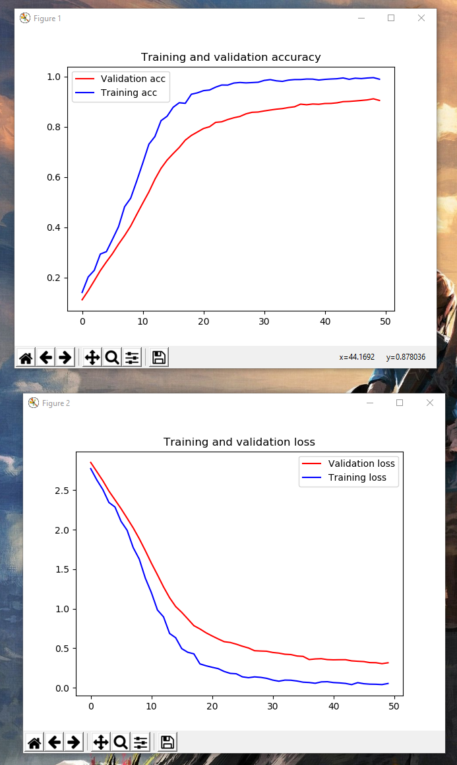

50 Classes; batch size = 128

steps_per_epoch = 50000/128 ; validation_steps =50000/128 , epochs = 50 ; image_size = (100,100)

/test_models/50class1562epoch.h5

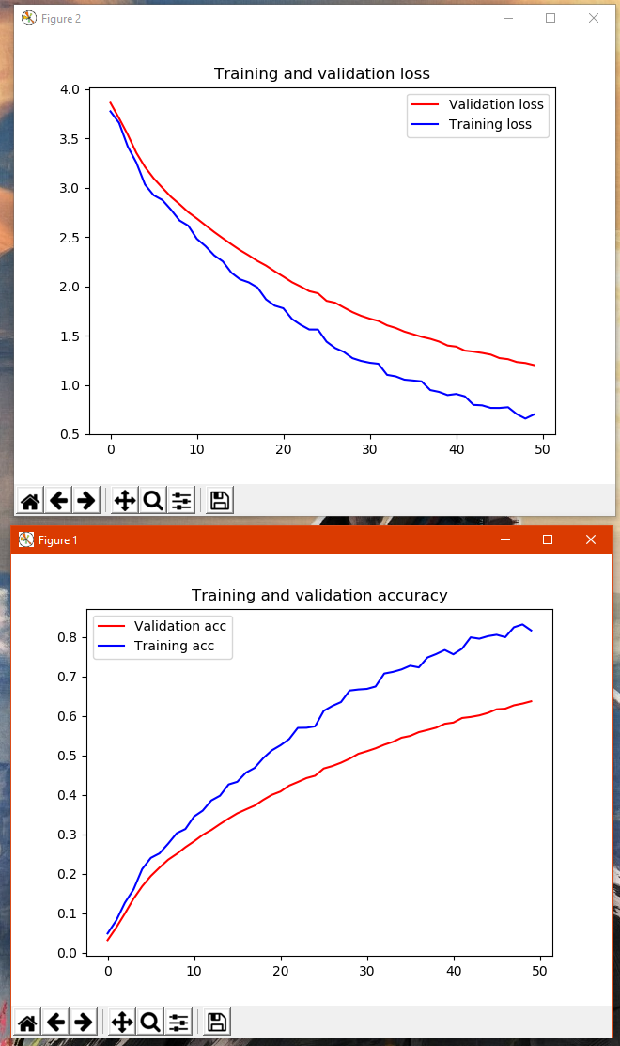

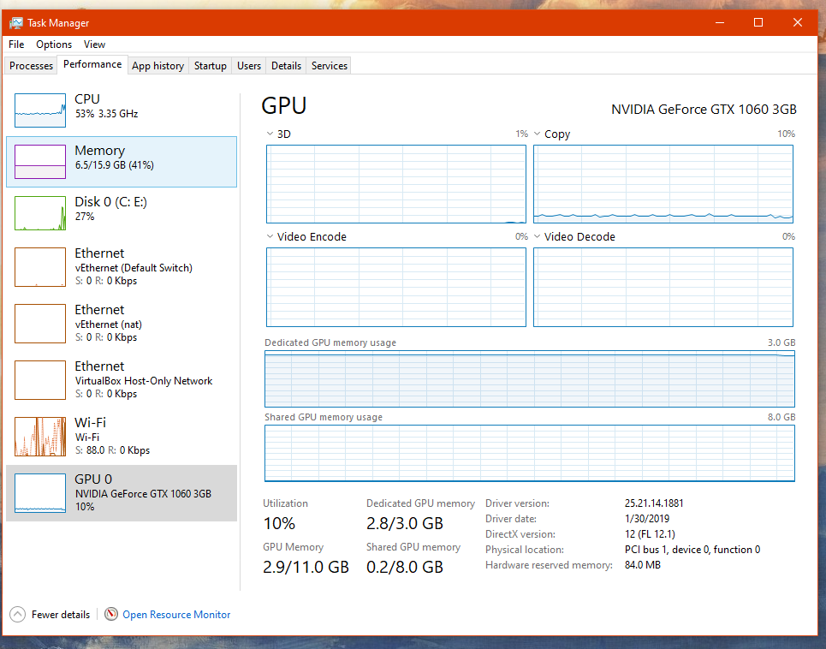

50 Classes; batch size = 128

steps_per_epoch = 50000/128 ; validation_steps =50000/128, epochs = 70 ; image_size = (100,100)

/test_models/50class70epoch.h5

